Step-by-Step Guide: Getting Started with Ethereum Mist(?) Wallet

1. Downloading the Ethereum Mist(?) Wallet:

To store, accept and send ether, you will need a wallet. For this you need to download the latest release of mist(?) wallet. Check the latest release and choose the release as per your system.

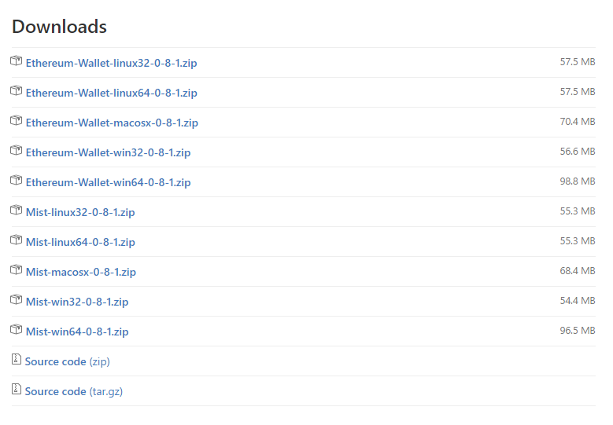

*Downloading the Ethereum Mist Wallet*

1. Select Ethereum-Wallet-(Your System).
2. Once you click the selected link, it will automatically start to download the zip file.

After unzipping the folder, look for Ethereum – Wallet application and launch it.

1. Installing the Wallet:

After launching you will see this:

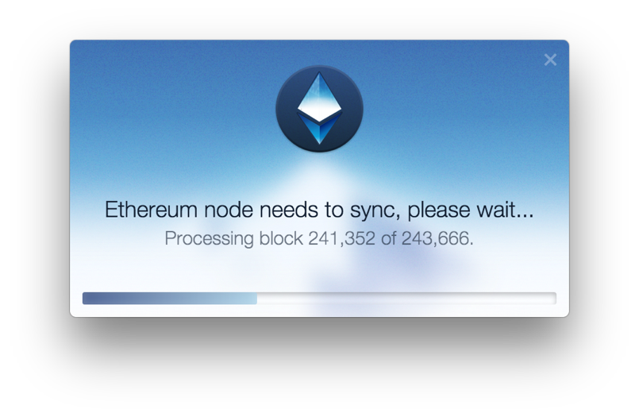

*Installing the Wallet*

Once the node is fully synced, you will be asked to choose the network. For testing purpose, choose ‘USE THE TEST NETWORK’ option.

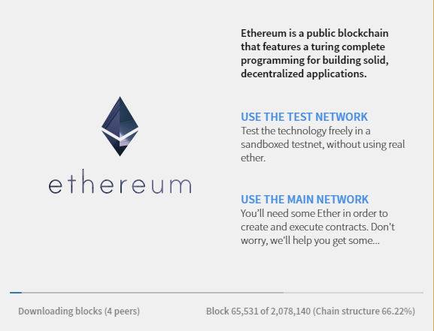

*Choose the TEST Network once Node is synced*

Set your password:

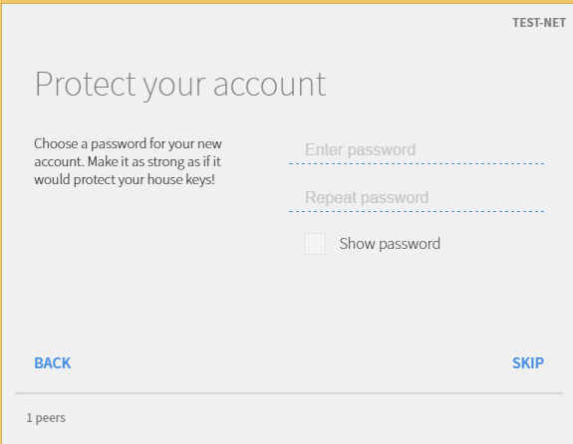

*Choose your Password*

1. Your Account:

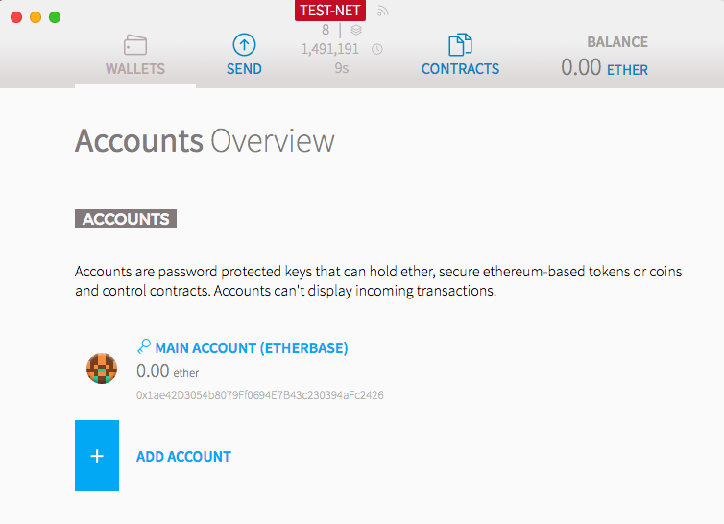

*Ethereum Mist(?) Wallet Account Overview*

This how the Wallet’s overview screen looks like.

At the top of your overview screen, you will see the information related to the sync status of your node. If the node has stopped syncing (e.g. zero peers or block numbers are not changing), try restarting the app or wait for some time.

Under Accounts, you can see the number of accounts and Ether balance in every account.

Your Account Address:

Go inside the ‘MAIN ACCOUNT’. The string below your account name is your account address. It starts with 0x.

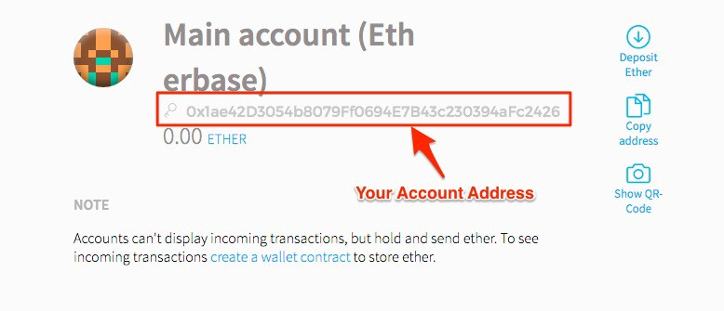

*Ethereum Mist Wallet – Your Account Address*

Note: Ethereum Account addresses are in hexadecimal format.

Sending Ether:

Go to send → Put in the address of the receiving party → Choose the amount of ether you want to send → Enter your password.

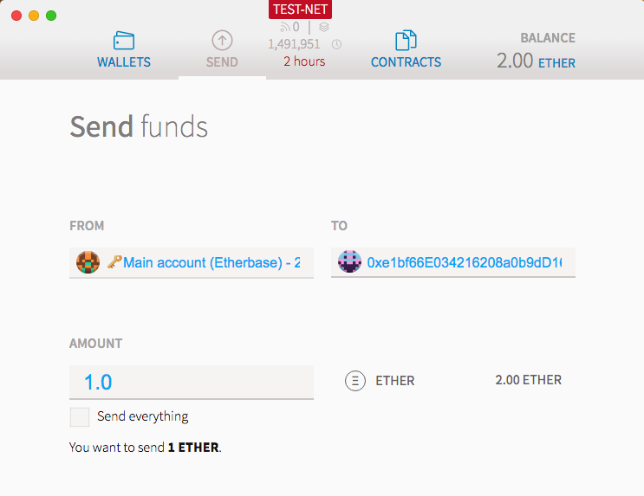

*Sending Ether from Ethereum Mist Wallet*

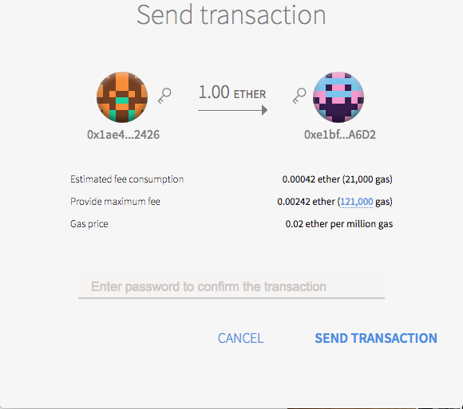

*Password – Sending Ether with Ethereum Wallet*

Your Transactions:

To see all of your transactions, go to Wallet overview → Latest Transactions.

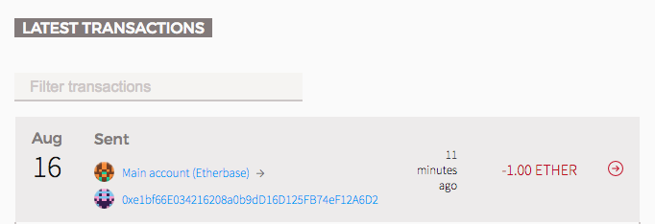

*Latest Transaction – Ethereum Wallet*

Click on the particular transaction to display the Transaction box.

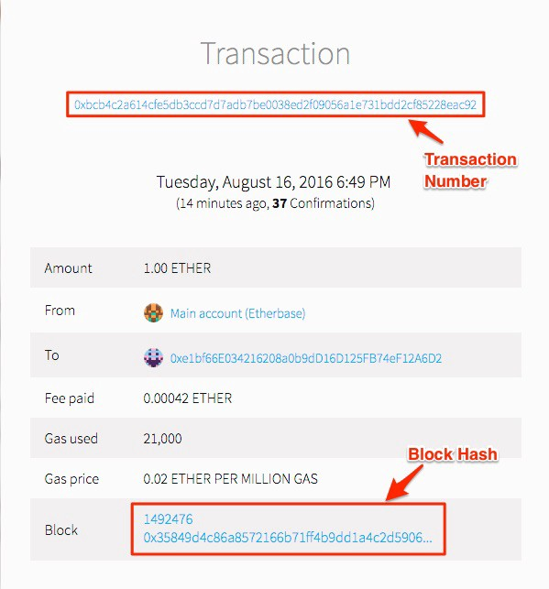

*Transaction Number & Block Hash – Ethereum Mist Wallet*